Super Blue Boy

# Level Overview

The player will start off in front of their home as they leave to go work after realising their car won’t start, they now have to parkour their way to work

# Art Style References

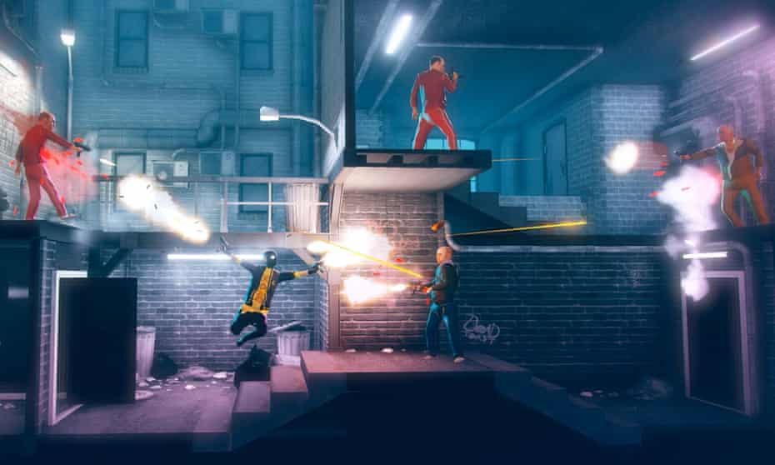

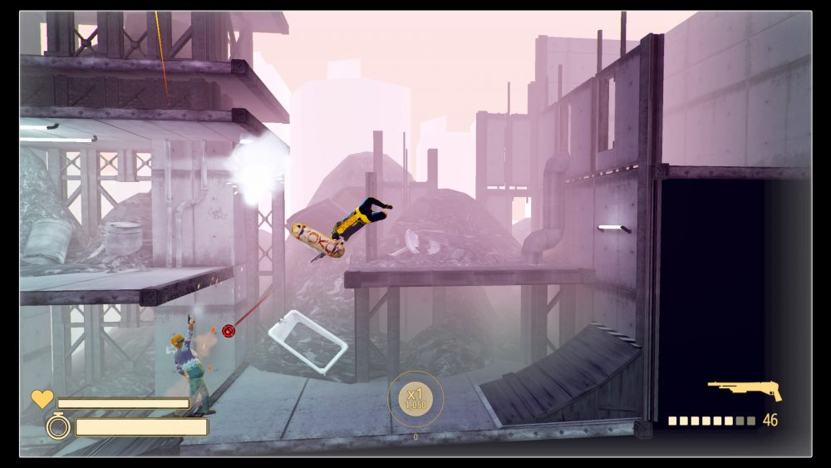

# Level 2D map

# MOOD BOARD

# Level changes